Closed-form solution for magnetic dipole SOURCE LOCALIZATION

Max Orman-Kollmar, Dartmouth College, Hanover, NH, USA  
Benjamin Barrowes, Cold Regions Research and Engineering Laboratory, Hanover, NH, USA  
Fridon Shubitidze, Dartmouth College, Hanover, NH, USA

Abstract

Recent advancements in atomic, lightweight, and compact magnetic sensing technologies have enabled the deployment of magnetic field sensors in various configurations, including full 3D setups, on moving platforms. As a result, high-density and high-quality data can now be collected in a relatively fast and cost-effective manner. To fully leverage these developments and enhance the detection and localization of subsurface magnetic anomalies in real-time, this paper presents a closed-form solution for locating magnetic dipoles from the complete 3D total magnetic field gradient. Synthetic data, along with an analytical derivation of this solution, is provided to demonstrate the accuracy and applicability of the proposed techniques for real-world scenarios. The results illustrate the effectiveness of this approach for depth estimation of a "buried" magnetic dipole, highlighting the potential and feasibility of this initial implementation.

Introduction

Magnetometers are a highly utilized advanced investigation sensor, which record magnetic field data at a given location. Specifically, they are used to detect ferrous anomalies by identifying perturbations in Earth’s magnetic field. Over the last 20 years and more, significant hardware iteration and design has been done to make magnetometers deployable in a variety of ways, such as mounted on drones or with multiple magnetometers in grouped configurations. The use cases for magnetometers range widely in field and application, such as ferrous-content improvised explosive device (IED) detection (Abdelrahman and Essa 2015; Liu and Wang 2010) or use in cancer detection and treatment efforts (Hathaway et al. 2011; Shubitidze et al. 2015). Many of these applications require the localization of magnetic anomalies. Overall, the localization of targets is a non-linear inverse problem. Solving this problem is time-consuming and unstable, particularly when estimating the location of magnetic dipoles from total magnetic fields. In addition to the needs for accurate localization, there is just as much need for *real-time* localization. Leveraging the small scale and lightweight implementations of magnetometers developed, it seems that the logical next step is implementing an array of magnetometers (Liu and Wang 2010) to provide the necessary data density for completely interrogating an area of interest.

To implement a real-time localization algorithm a closed-form analytical solution is derived. The following sections present the derivation of this solution, a synthetically generated data set to test the accuracy of the proposed initial implementations, followed by a discussion of and conclusions drawn from the synthetic data.

Analytical Solution Derivation and Simulations

To find the closed-form solution, we propose an array of several total-field magnetometers. Using a setup of multiple magnetometers allows for use of magnetic field data at each specific point, as well as the gradient data across a given axis (You et al. 2022; Wang et al. 2016; Fan et al. 2016; Wynn 1997). The separation distances between magnetometers can be the same, or it can vary between pairs, allowing for potentially different strengths in readings at different test locations. An example setup can be seen in Figure 1. The desired solution then uses only collected information, such as the magnetic field readings and the observation point location, not relying on geographical factors such as local inclination or declination of Earth’s magnetic field.

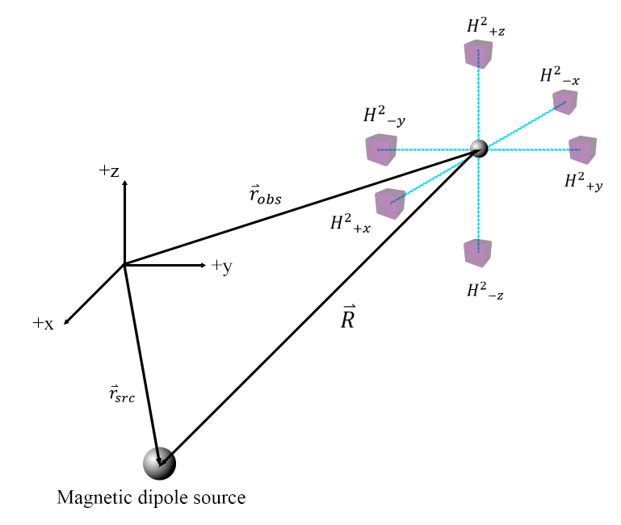

**Figure 1:** Six magnetometer example setup. The array of magnetometers, each represented by a purple cube, is shown on the right-hand side. The magnetic dipole source and center of the magnetometer array are referenced to a local origin.

Closed-Form Solution Derivation

Starting from the magnetic field due to a magnetic dipole (Zangwill 2012):

$$\begin{aligned}H=\frac{1}{4π}\left(\frac{3R(m∙R)}{R^{5}}-\frac{m}{R^{3}}\right) \\ R≝r_{obs}-r_{src}, R≝r_{obs}-r_{src}\end{aligned}$$

**Equation 1**: The magnetic field resulting from a magnetic dipole.

Considering the total field measured by each magnetometer as $H^{2}$:

$H^{2}={\left(\frac{1}{4π}\right)}^{2}\left(\frac{3{(m∙R)}^{2}}{R^{8}}+\frac{m^{2}}{R^{6}}\right)$

**Equation 2**

Including the magnetic scalar potential $Ψ=\frac{1}{4π}\frac{m∙R}{R^{3}}$ (Demarest 1998) into Equation 2 and reordering terms:

$${R^{6}H}^{2}=3R^{4}Ψ^{2}+\frac{m^{2}}{{\left(4π\right)}^{2}}$$

**Equation 3**

Evaluating the gradient of Equation 3 using the definition of $H= -∇Ψ$:

$${{6R}^{4}RH}^{2}+R^{6}∇\left(H^{2}\right)=12R^{2}RΨ^{2}-6R^{4}ΨH$$

**Equation 4**

Taking the dot product of Equation 4 with $R$ results in:

$$R∙∇\left(H^{2}\right)=-6H^{2}$$

**Equation 5**

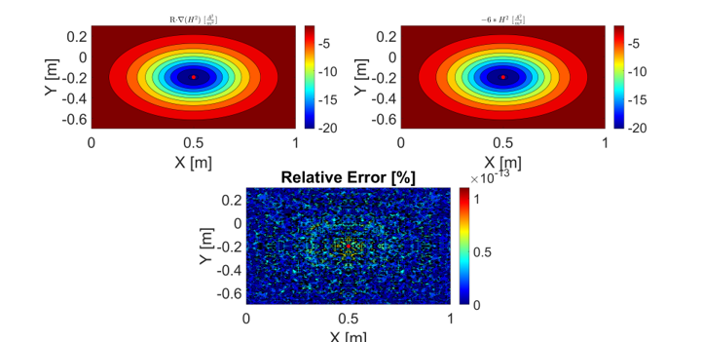

**Figure 2:** Verification of Equation 5.

Simplifying $R$ back into its component form as defined in Equation 1:

$$r_{src}∙∇\left(H^{2}\right)=r_{obs}∙∇\left(H^{2}\right)+6H^{2}$$

**Equation 6:** Final closed-form solution.

### Numerical Simulation and Implementation

To test the feasibility of this closed-form solution’s implementation, a numerical simulation was put into place. To solve this inverse problem, where the desired output is a single 3x1 vector of coordinate components at any given point in space, a matrix formulation of $\underline{A}x=b$ is the most intuitive to apply, with the solution to this being of form $x={\underline{A}}^{-1}b$:

$\left[\begin{matrix}{r_{src}}_{x} \\ {r_{src}}_{y} \\ {r_{src}}_{z}\end{matrix}\right]={\left[\begin{matrix}\frac{∂H_{1}^{2}}{∂x} & \frac{∂H_{1}^{2}}{∂y} & \frac{∂H_{1}^{2}}{∂z} \\ \frac{∂H_{2}^{2}}{∂x} & \frac{∂H_{2}^{2}}{∂y} & \frac{∂H_{2}^{2}}{∂z} \\ \frac{∂H_{3}^{2}}{∂x} & \frac{∂H_{3}^{2}}{∂y} & \frac{∂H_{3}^{2}}{∂z}\end{matrix}\right]}^{-1}*\left[\begin{matrix}{r_{obs}}_{x1}*\frac{∂H_{1}^{2}}{∂x}+{r_{obs}}_{y1}*\frac{∂H_{1}^{2}}{∂y}+{r_{obs}}_{z1}*\frac{∂H_{1}^{2}}{∂z}+6H_{1}^{2} \\ {r_{obs}}_{x2}*\frac{∂H_{2}^{2}}{∂x}+{r_{obs}}_{y2}*\frac{∂H_{2}^{2}}{∂y}+{r_{obs}}_{z2}*\frac{∂H_{2}^{2}}{∂z}+6H_{2}^{2} \\ {r_{obs}}_{x3}*\frac{∂H_{3}^{2}}{∂x}+{r_{obs}}_{y3}*\frac{∂H_{3}^{2}}{∂y}+{r_{obs}}_{z3}*\frac{∂H_{3}^{2}}{∂z}+6H_{3}^{2}\end{matrix}\right]$

**Equation 7:** Matrix formulation.

Once the analytical solution has been verified, Equation 7 is implemented to extract source location information.Figure 3 shows an example location estimation.

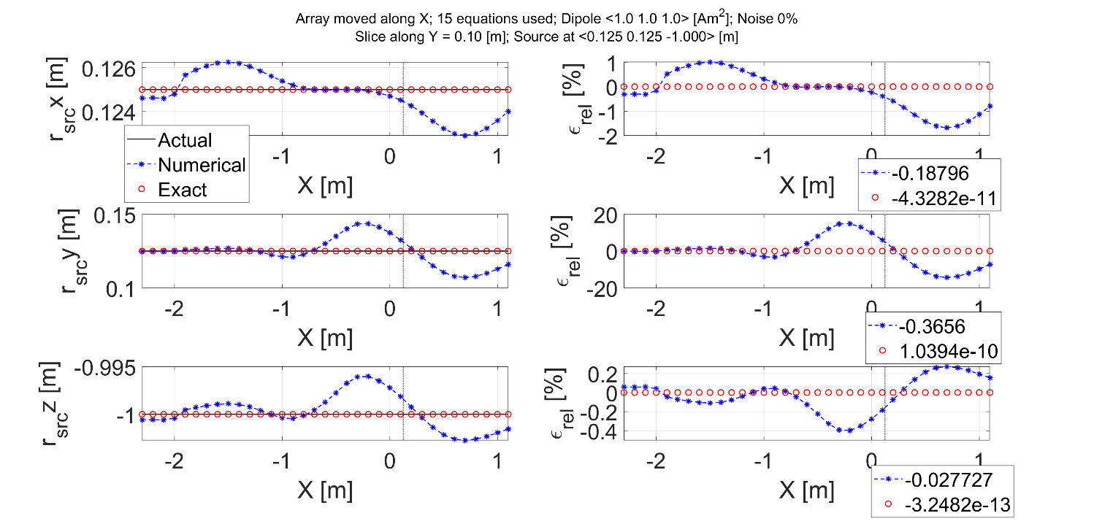

**Figure 3:** Location estimate resulting from implementing an analytical solution as well as the proposed numerical solution, shown along a single x-direction pass. The left three graphs show the estimated x-, y-, and z-coordinates from the numerical approach (compared to the analytical one). The right graphs show the relative error of both approaches, with the legends showing the average error for this pass of the area.

As seen in Figure 3, the initial application using synthetic data does not provide an exact depth estimate. At the (X,Y) coordinate of the source, denoted by the vertical dotted line in each plot, the depth estimate is less than 0.5cm off. However, x- and y-coordinate estimates have larger error.

Conclusions

A closed-form solution for localizing a magnetic dipole is derived using the total magnetic field's 3D gradient. Comparisons between the analytical and numerical approximations demonstrate that the equation holds.

Preliminary results for estimating the depth of a tilted dipole show good agreement between the estimated and actual depth. However, further improvements could be achieved by optimizing sensor placement and increasing the number of data points.

Additionally, to fully assess the applicability of the proposed closed-form solution for detecting and localizing a responding magnetic dipole, actual magnetic data must be collected under real field conditions and processed using the closed-form solution.

References

Abdelrahman, E. M., and K. S. Essa. 2015. “A New Method for Depth and Shape Determinations from Magnetic Data.” *Pure and Applied Geophysics* 172 (2): 439–60. https://doi.org/10.1007/s00024-014-0885-9.

Demarest, Kenneth Robert. 1998. *Engineering Electromagnetics*. Internat. ed. Upper Saddle River, N.J: Prentice Hall.

Fan, Liming, Chong Kang, Xiaojun Zhang, Quan Zheng, and Ming Wang. 2016. “An Efficient Method for Tracking a Magnetic Target Using Scalar Magnetometer Array.” *SpringerPlus* 5:502. https://doi.org/10.1186/s40064-016-2170-0.

Hathaway, Helen J, Kimberly S Butler, Natalie L Adolphi, Debbie M Lovato, Robert Belfon, Danielle Fegan, Todd C Monson, et al. 2011. “Detection of Breast Cancer Cells Using Targeted Magnetic Nanoparticles and Ultra-Sensitive Magnetic Field Sensors.” *Breast Cancer Research* 13 (5): R108. https://doi.org/10.1186/bcr3050.

Liu, Renhao, and Hua Wang. 2010. “Detection and Localization of Improvised Explosive Devices Based on 3-Axis Magnetic Sensor Array System.” *Procedia Engineering* 7:1–9. https://doi.org/10.1016/j.proeng.2010.11.001.

Shubitidze, Fridon, Katsiaryna Kekalo, Robert Stigliano, and Ian Baker. 2015. “Magnetic Nanoparticles with High Specific Absorption Rate of Electromagnetic Energy at Low Field Strength for Hyperthermia Therapy.” *Journal of Applied Physics* 117 (9): 094302. https://doi.org/10.1063/1.4907915.

Wang, Chen, Xiaojuan Zhang, Xiaodong Qu, Xiao Pan, Guangyou Fang, and Luzhao Chen. 2016. “A Modified Magnetic Gradient Contraction Based Method for Ferromagnetic Target Localization.” *Sensors (Basel, Switzerland)* 16 (12): 2168. https://doi.org/10.3390/s16122168.

Wynn, W.M. 1997. “Magnetic Dipole Localization with a Gradiometer: Obtaining Unique Solutions.” In *IGARSS’97. 1997 IEEE International Geoscience and Remote Sensing Symposium Proceedings. Remote Sensing - A Scientific Vision for Sustainable Development*, 4:1483–85. Singapore: IEEE. https://doi.org/10.1109/IGARSS.1997.608906.

You, Haidong, Jindong Li, Jun Xu, Jian Xu, Tigang Ning, Yuanyuan Gao, and Lin Li. 2022. “A Method for Estimating Magnetic Target Location by Employing Total Field and Its Gradients Data.” *Scientific Reports* 12 (1): 17985. https://doi.org/10.1038/s41598-022-22725-9.

Zangwill, Andrew. 2012. *Modern Electrodynamics*. Cambridge: Cambridge University Press. https://doi.org/10.1017/CBO9781139034777.

Acknowledgements

This work was funded by the National Science Foundation (NSF) grant DGE2125733 and the Office of Naval Research under grant # N00014-22-1-2396. Any opinions, findings, and conclusions or recommendations expressed in this material are those of the author(s) and do not necessarily reflect the views of the funding organizations.