A Combined electromagnetic induction-magnetometer sensing approach for detecting subsurface targets

Max Orman-Kollmar, Dartmouth College, Hanover, NH, USA  
Randall Reynolds, Dartmouth College, Hanover, NH, USA   
Rui Zhang, Geometrics Inc., San Jose, CA, US,   
Benjamin Barrowes, Cold Regions Research and Engineering Laboratory, Hanover, NH, USA  
Fridon Shubitidze, Dartmouth College, Hanover, NH, USA

Abstract

This work presents a joint application of a magnetometer and a time-domain electromagnetic induction sensor for detecting, localizing, and identifying deep targets. By combining these sensors, the aim is to use a magnetometer for recording transient magnetic fields at late times, while employing Time Domain Electromagnetic Induction (TDEMI) sensing at early times, to detect both ferrous and non-ferrous materials. Although magnetometers are widely used to sense the Earth's magnetic field and its disturbances caused by ferrous anomalies, this study employs an active TDEMI transmitter to illuminate subsurface metallic targets from various orientations and angles. The preliminary measured EMI and magnetometer data are demonstrated for aluminum, brass, and steel medium-sized industry-standard pipes.

Introduction

Detecting and identifying subsurface anomalies is an enduring problem, whether the target of the search is underground infrastructure, compact manmade objects (Pei and Yeo 2009); or even mineral deposits (Kowalczyk 2011). While advanced EMI sensors and innovative signal processing techniques have shown excellent performance in the detection, localization, and classification of near-surface targets (approximately 11 times the target's diameter), a more robust sensing approach is still needed for detecting and classifying deeper targets. One possible approach involves combining active EMI with state-of-the-art fast sampling magnetometers.

Time-domain electromagnetic induction (TDEMI) systems typically are comprised of both active and passive coils and operate at frequencies typically under 100kHz. The active, or transmitter, coils produce a pulsed primary magnetic field when a pulsed current is run through them. The primary magnetic field then penetrates the ground, where it decays away if no conducting targets are present. In the presence of conducting targets, however, the primary magnetic field induces eddy currents in the target, which then create a secondary magnetic field. This secondary field then passes through the receiver coils and generates data in the form of sampled electromotive force (voltage).

There are two difficulties presented by utilizing a TDEMI system, particularly for the deep target problem. The first issue is the saturation from the primary field in the receivers. The primary field generated needs time to collapse, and until it has fully decayed away, the early times data seen by the receivers is not reliable for target detection and discrimination. This issue is a hardware problem, as it requires the generated current pulse to shut on and off quickly, as well as having a low enough inductance in the transmitter coils to allow the primary field to dissipate quickly.

The second issue complicating deep target detection with a TDEMI system is the signal’s fast decay at late times. EMI suffers from a “weak” detection depth, as the secondary magnetic field produced decays as 1/R5 or 1/R6, with R being the distance from the target to the receiver coils (Jackson 1999). The further away the target is from the system, the faster the secondary magnetic signal decays at the receivers. As a result, later time signals are difficult to distinguish from background noise. This problem is directly tied to the physics of electromagnetic signals and is difficult to overcome. This combination of early time saturation and late time decays make deep target detection and classification a particular challenge for TDEMI systems.

Magnetometers, in contrast, are passive sensors that measure magnetic fields, and are often used to measure the Earth’s magnetic field and perturbations therein. Use cases include detecting and locating small, isolated ferrous targets (Pei and Yeo 2009), as well as for conducting geophysical surveys to uncover mineral deposits (Kowalczyk 2011). Recently developed sensitive atomic magnetometers, such as Geometrics, Inc.’s Micro-Fabricated Atomic Magnetometer (MFAM) and the QuSpin Inc. atomic magnetometer, have opened ways to further enhance magnetic anomalies’ detection and localization, which makes them well suited for finding deeper ferrous anomalies. These magnetometers are not only highly sensitive, able to detect low magnitude changes in the local magnetic field caused by magnetic anomalies, but the they can sample signals at a 2kHz rate and store them for post-processing, allowing for very dense data collection over areas of interest. Although passive magnetic field sensors are good for deep target detection, there are several drawbacks of using them: 1. They rely on the Earth's magnetic field as the primary means for illuminating targets, which limits target classification through magnetic data. 2. They can only detect ferrous or ferromagnetic targets. These problems can be addressed by combining the active EMI and magnetometer systems.

The following sections present the methodology and testing used to investigate the usage of a joint magnetometer and TDEMI system, followed by a presentation of selected data, and discussion of and conclusions drawn from the data.

Methodology and Testing

To perform the testing and data collection, an active EMI transmitter was set up above a magnetometer and passive EMI receiver, allowing for a direct comparison between the recorded responses in each modality. An adjustable platform was used to place targets at different depths relative to the active transmitter, as shown in Figure 1. Three different medium Industry Standard Object (ISO) pipe sections are shown (aluminum, brass, and steel), in a horizontal orientation. The transmitter runs a pulsed current through the transmitter coil, generating the time-varying magnetic field. In this particular case, the 1-meter diameter coil carries a pulsed transmitter current with 20-millisecond on- and off-periods.

Data collection was performed in two instances (“static” and “dynamic”) for each target at different depth and orientation: 1. A “static” collection where the active EMI transmitter was off, recording the targets’ responses solely due to Earth’s static field. 2. A “dynamic” collection where the active EMI transmitter was on, recording the responses due to the time-varying primary field as well as Earth’s static one. Additionally, one static and dynamic collection each were recorded with no targets present, to use as a reference for background data subtraction.

Extracting the signals from the magnetometer is a multi-step process. The first step is stacking and averaging the collected dynamic data. The second is then removing both the static and dynamic background, as well as static target responses from the active target response data. Once all of the external responses are removed, the individual targets’ decays become distinguishable.

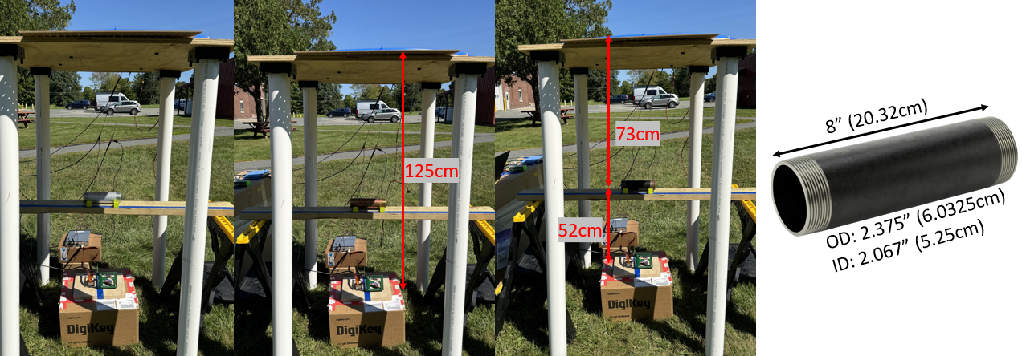

**Figure 1:** Example testing setup, showing the distance between transmitter and receiver, as well as three different medium pipe sections used as targets.

Response Comparison

Figure 2 shows the response of all three medium ISO pipes, laying horizontally at 73cm below the transmitter. The four subdivisions of the top graph denote the 20-millisecond on- and off-periods of the active transmitter for the 80-millisecond cycle. In the regions between 30-40 milliseconds and 70-80 milliseconds, the decays of the three different materials are distinguishable. By contrast, the responses recorded in the EMI receiver, shown in the bottom graph, are not differentiable between each other, indicating that the targets are too “deep” for detection with just the EMI sensor.

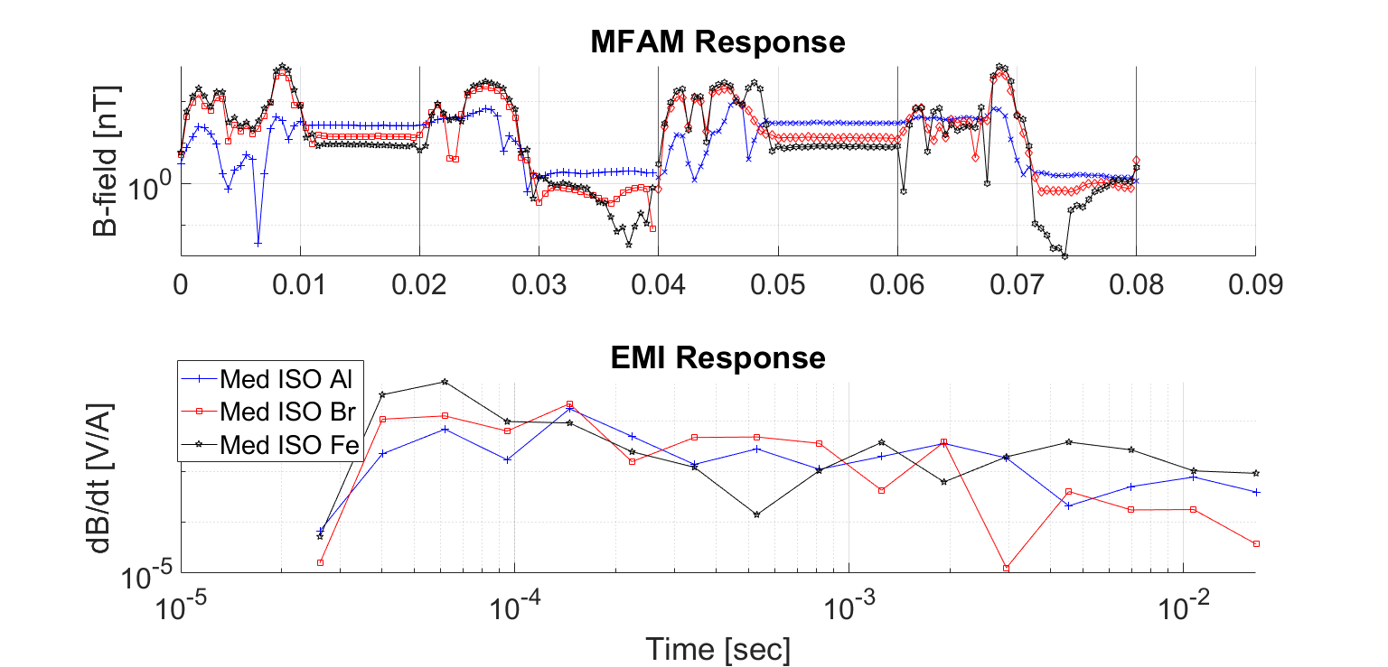

**Figure 2:** A comparison of the data collected using the MFAM (top) and the passive EMI receiver (bottom), for the three different pipe sections at 73 cm away from the active transmitter.

The 0-10 millisecond and 40-60 millisecond windows, the on-period, saturate the magnetometers. After the current is shut off, there is an additional 10 milliseconds where the magnetic field recorded seems to be behaving erratically. This is a result of the sudden and sharp change in magnetic field overwhelming the magnetometers, causing the sensor to temporarily lose its lock. As the magnetometer levels itself out, the magnetic field readings reemerge, showing the target responses.

Conclusions

Initial findings indicate that the use of joint EMI-magnetometer data allows for deeper detection depth than using data from the EMI sensor alone. Additionally, using the joint sensor configuration allowed for material differentiation in the magnetometer, even distinguishing between ferrous non-ferrous materials. Further investigation will focus on improving the data processing algorithms for cleaner extraction of data, as well as work on applying identification capabilities to the processed data.

From this initial testing and data collection, there is a clear limitation on how close the magnetometers and EMI transmitter can be together. The large and sudden change in magnetic field produced by the transmitter overwhelms the magnetometer, requiring a settling time for the data collected to be viable. Ways to mitigate this interference will be investigated further, such as focusing on optimizing separation distances and placements between magnetometer and EMI transmitter.

References

Jackson, J. D. 1999. *Classical Electrodynamics*. 3rd ed. New York: John Willey & Sons.

Kowalczyk, Peter. 2011. “Geophysical Exploration for Submarine Massive Sulfide Deposits.” In *OCEANS’11 MTS/IEEE KONA*, 1–5. Waikoloa, HI: IEEE. https://doi.org/10.23919/OCEANS.2011.6107069.

Pei, Y. H., and H. G. Yeo. 2009. “UXO Survey Using Vector Magnetic Gradiometer on Autonomous Underwater Vehicle.” In *OCEANS 2009*, 1–8. Biloxi, MS: IEEE. https://doi.org/10.23919/OCEANS.2009.5422446.

Acknowledgements

This work was funded by the National Science Foundation (NSF) grant DGE2125733 and the Office of Naval Research under grant # N00014-22-1-2396. Any opinions, findings, and conclusions or recommendations expressed in this material are those of the author(s) and do not necessarily reflect the views of the funding organizations.