**Applying a Blue UAS to Collect Magnetic and EM Data**

Ronald S. Bell, Drone Geoscience, LLC, Lakewood, Colorado

# Abstract

Collecting magnetic and electromagnetic data using an unoccupied aerial vehicle (UAV) over a Department of Defense (DOD) property is restricted to aircraft designated as Blue UAS by the Defense Innovation Unit (DIU). An added complication is the limited number of heavy lift aircraft on the list. Inspired Flight Technologies, Inc. of San Luis Obispo, CA makes a heavy lift hexacopter UAV, the IF1200A, which has a lift capacity for lifting geophysical sensors more than 7 kg and was officially placed on the Blue UAS in September 2023.

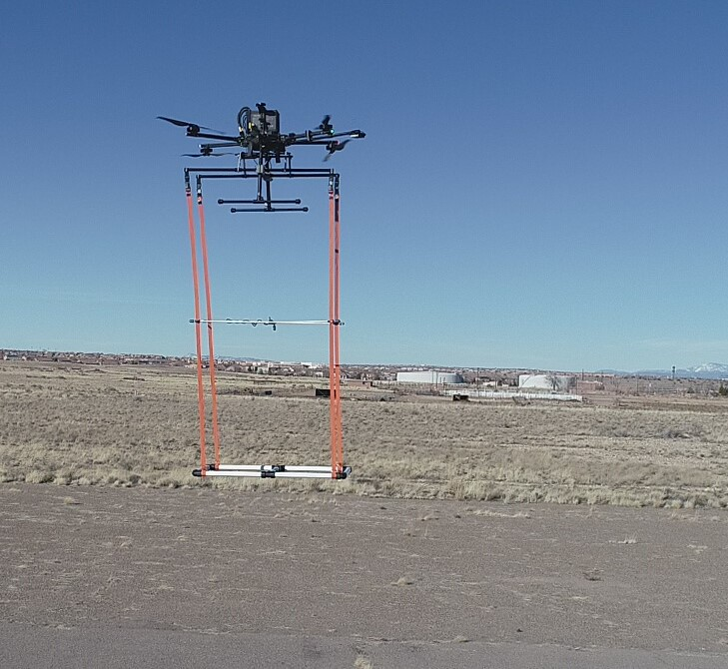

EM61Lite suspended under IF1200A

However, 50% of the propellers are located below the motor arms. The UAV design required fabricating a geophysical payload suspension system (GPSS) specifically for the IF1200A that facilitated the rapid replacement of one type of geophysical sensor system (e.g. magnetometer) with another (e.g. EM metal detector). To conduct missions at ultra-low altitudes ( i.e. below 5 meters AGL), a radar or laser altimeter is integrated with the IF1200A to maintain constant, accurate height of the UAV and sensor above ground level.

The IF200A with the radar altimeter and GPSS was deployed to collect magnetic data over a tightly configured geophysical survey gridded seeded with UXO industry standard objects (ISOs). Then the survey was repeated with the ***EM61Lite*** made by Geonics, Ltd shown in the photograph.

The results of the magnetic and EM61Lite field trials will be presented.